Render in Place for a non working outer timeline
If you find your inner timeline is working but the main timeline is not. This is a good time to use Render in Place again.
Go inside the timeline where the vine mask animation works.
Make sure Awedae/chair/vines all play correctly there. Select all of the clips or compound clip.
Right-click → Render in Place.

Use a good format like:
QuickTime
DNxHR HQ / HQX if available
or a high-quality H.264 if space matters

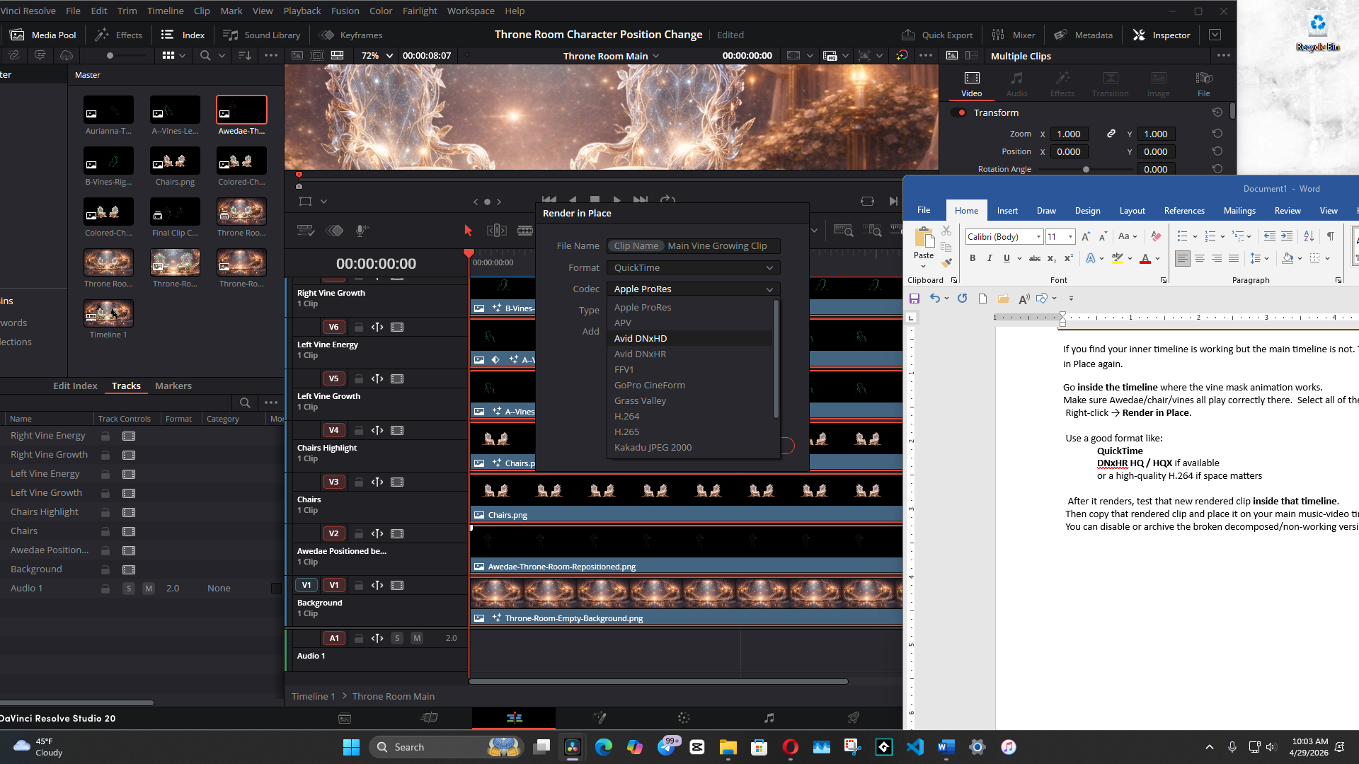

It might want you to give the folder that it choose to save this in, a little click. Before it will start to render.

After it renders, test that new rendered clip inside that timeline.
Then copy that rendered clip and place it on your main music-video timeline.
You can disable or archive the broken decomposed/non-working version.

